STFC SHE Training for Technical Managers Course Workbook
Note: This document contains the exercises to be use as part of the above course.

Name _____________________________

STFC SHE Training for Technical Managers
Course Programme: Day 1
** Note that the times given are approximate and will be adjusted to suit programme requirements **

Session Number | Session Title | Time
1 | Director’s Introduction  Course Introductions  Aim and Objectives | 09:00 to 09:45
2 | Motivations for SHE Management  UK and STFC H&S performance overview | 09:45 to 10:45
 | Break | 10:45 to 11:00
3 | Legal duties and safety management systems (general) | 11:00 to 12:30
 | Lunch | 12:30 to 13:30
4 | STFC’s Safety Management System and Policy  SHE Website and IT Systems | 13:30 to 15:00
 | Break | 15:00 to 15:15
5 | Safety code reviews | 15:15 to 16:45

STFC SHE Training for Technical Managers
Course Programme: Day 2

** Note that the times given are approximate and will be adjusted to suit programme requirements **

Session Number | Session Title | Time
1 | Issues and questions from Day 1  Risk Assessment part 1: Nature of risk assessment and STFC’s arrangements | 09:00 to 10:45
 | Break | 10:45 to 11:00
2 | Risk Assessment part 2: Individual and group review of risk assessments | 11:00 to 12:30
 | Lunch | 12:30 to 13:30
3 | Accident causation and investigation and exercise  (incl. Break) | 13:30 to 16:00
4 | Environmental management in STFC | 16:00 to 16:45

STFC SHE Training for Technical Managers
Course Programme: Day 3

** Note that the times given are approximate and will be adjusted to suit programme requirements **

Session Number | Session Title | Time
1 | Issues and questions from Day 2  Review of environmental Codes  Safety training and Training Needs Analysis | 09:00 to 10:45
 | Break | 10:45 to 11:00
2 | Audit, inspection, and improvement plans  Contractors | 11:00 to 12:45
 | Lunch | 12:45 to 13:30
3 | Safety culture, leadership and supervision  Course conclusion | 13:30 to 15:15
 | Break | 15:15 to 15:30
4 | Issues and questions from all 3 days  Course assessment | 15:30 to 16:45

SHE Training for Technical Managers Course
Personal Action Log
Session Title | Action | Notes

STFC SHE
Training for Technical Managers Course

Exercises

Exercise 1

The following are examples of STFC SHE incidents.
Please look at these examples consider if and how they may be preventable through management actions.
For each incident (as presented only), what are the possible management issues which may need addressing?

Group A
No. | Incident description | Response
1 | Gas cylinder pulled over whilst moving equipment within a laboratory. (Gas cylinder was connected to equipment via a braided hose).
2 | FLT operator entered into pedestrian walkway attempting to access Laboratory without deploying a tensa-barrier.
3 | IP tripped on an uneven floor in corridor to locker room, this issue had already been reported previously.
4 | Contractor attempted to move plasterboard which subsequently fell on him, injuring his leg.

Group B
No. | Incident description | Response
5 | Removed plug from wall mounted socket, back of plug fell off and IP received an electric shock when contacting with the live terminals.
6 | Minor scald at hot water dispenser when I looked away and my hand holding the cup was scalded.
7 | Suspected asbestos sheet found during routine disposal of old computer racking.
8 | Hedge cutting contractors seen working at height from the back of a flatbed truck. Operator remained standing on the truck as it was driven forward to the next section of hedge to be cut.
Group C
No. | Incident description | Response
9 | Contractor cut scaffold poles without hot works permit. A hot work permit was in place for the principal contractor but a sub-contractor carried out the cutting of the pole without knowledge of the permit.
10 | Lack of appropriate PPE being worn during cryogenics operation.
11 | IP was constructing some flat-pack trollies and caught their hand between the pole and the shelf. Minor first aid injury occurred.
12 | Two large plastic measuring cylinders found on the bottom shelf of a drying cabinet. The shelf was extremely hot to the touch, even with a heat proof glove on.

Exercise 2: Opening review of management responsibilities
The table below summarises the delegation of safety responsibilities to all STFC Mangers in Section 3.2 of the STFC H&S Management Arrangements - use the laptops to look at full wording.
Make an initial assessment of the status of these responsibilities in your own work environment and consider what actions you think may be necessary for you at this stage. We will re-visit this table towards the end of the course.
Management Responsibility | Your Present Situation. | Thoughts on future management actions required.
Codes
Implementing the H&S standards and controls set out in STFC SHE Codes and management systems, ensuring adequate monitoring of H&S performance.
Risk assessment
Identifying hazards in your delivery areas, assessing the risks these pose to the H&S of your staff and others, identifying and implementing suitable control measures, communicating the outcome of the assessment to those who are affected.
Training
Ensuring your staff are competent via the provision of suitable information, instruction and training and experience to undertake their tasks.
Premises and equipment
Ensuring any premises, plant and equipment under your control are safe and adequately maintained, including the arrangements for safe evacuation in the event of a fire or other emergency.
Supervision
Provide adequate supervision of work and the workplace to ensure that H&S standards are maintained for staff and others working on STFC sites.
Incident reporting
Encouraging the reporting of all injuries and incidents and ensuring any incidents under your authority are investigated by line managers, drawing on competent advice as necessary, to determine immediate and root causes and acting on the investigation findings to minimise the likelihood of recurrence.
Staff consultation
Consulting staff and others working under your authority on H&S matters to enable improvement to arrangements and performance and share lessons identified across STFC.
Personal commitment
Demonstrating your commitment to the health, safety and welfare of those under your authority and others affected by your activities and thus promote a positive safety culture.
Appendix 2 – Staff and non-STFC people
Shared responsibilities and duty to agree where there is a possibility of doubt/confusion
Exercise 3: Code Familiarisation
Which SHE Codes apply to your work, department, activities, or staff and are most important to you?
5 Main Work Activities | Applicable SHE Codes and title | Implementation?  None – Partial – Full | Notes

Exercise 4: SHE Code Review
Guidance for the SHE Code summary presentation exercise

Group 1 - SHE Code 12: Safe Manual Handling Operations
The purpose of this exercise is to prepare a short presentation for the course summarising the implications of the code for line managers or supervisors in a technical environment.
The presentation should last no more than 5 minutes, and include at least the following at bullet level:
- Which statutory regulations apply?
- What do these regulations require at the top level?
- A bulleted summary of the main responsibilities of the Group Leader and the Line Manager.
- A summary of assistance available in the code appendices.
- A summary of the mandatory training arrangements

Group 2 - SHE Code 32: Fire and Emergency Management
The purpose of this exercise is to prepare a short presentation for the course summarising the implications of the code for line managers or supervisors in a technical environment.
The presentation should last no more than 5 minutes, and include at least the following at bullet level:
- The responsibilities of Estates Groups
- The responsibilities residing in Departments
- Examples of the critical fire and emergency safety systems
- The relationship between Building Fire Managers and Fire Safety Advisers
- The responsibilities of Line Managers and Contract Supervising Officers

Group 3 - SHE Code 09: Work at Height
The purpose of this exercise is to prepare a short presentation for the course summarising the implications of the code for line managers or supervisors in a technical environment.
The presentation should last no more than 5 minutes, and include at least the following at bullet level:
- Which statutory regulations apply?
- What do these regulations require at the top level (as summarised in section 1 of the code)?
- A bulleted summary of the main responsibilities of Managers and Supervisors. How would you categorise them?
- A summary of assistance available in the code appendices.
- A summary of the mandatory training arrangements for staff and managers

Risk Assessment Practical
Develop a risk assessment and submit to Laura Davies within 2 weeks.
The risk assessment can be:
- One developed for your own workplace (preferred), or
- One of the examples in the course materials:
  - Building inspection using a MEWP - Risk Assessment Exercise No1.
  - Construction of a ‘lead castle’ for an experiment - Risk Assessment Exercise No2.
Risk Assessment Exercise No1 - MEWP example
The Scenario:
A member of staff, Jack Thomas from Technology, has been asked to inspect a section of roof on a building at the site Laboratory. This will involve the use of a Mobile Elevated Work Platform (MEWP) which is parked in a shed nearby.
Jack will inspect the roof whilst standing in the MEWP (no climbing on the roof involved). Jack will be working with one other person who will act as a banksman.
Please write a risk assessment for this task covering the activities:
- Moving the MEWP from the shed to the building;
- Choosing the best location for the MEWP at the base of the building; and
- Operating the MEWP.
Either use the STFC proforma or complete an entry directly into Evotix Assure.
Notes: When setting up a MEWP [see pic 1] you need to ensure the ground is stable, level, strong enough to take the weight and the outriggers are in place (these are the extendable legs that make the MEWP stable).
- When in the bucket [seep pic 2], the operator would be attached via their harness to prevent a fall and they themselves would control the ascent/descent.
- The PPE required to work at height would be: safety shoes, overalls, harness and hard hat.
- In addition, jewellery must be removed, and long hair tied back.
- Weather forecast for the day: light winds, high of 11ºC with a chance of showers.

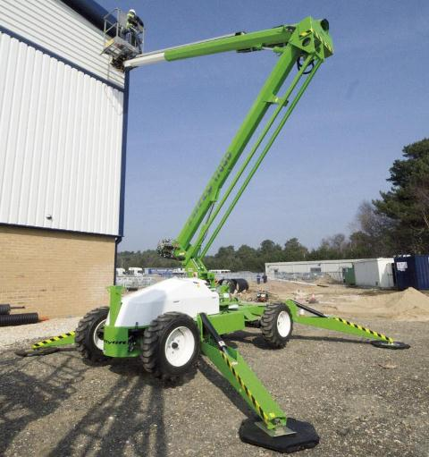 | Pic 1: The type of MEWP used to access the roof.  Outriggers are deployed (stabilising arms) | 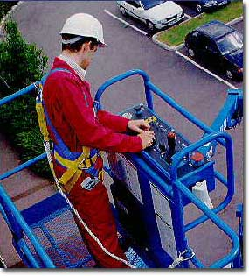 | Pic 2: An example of an operator ascending in the bucket of the MEWP.

List of Hazards which may apply
Physical injury hazards
- Mobile plant/pedestrians in same area
- Slips trips and falls
- Moving parts of machinery
- Pressure systems
- Manual handling
- Working with mains electricity
- Working at Height/Roof Access
- Hot work
- Access and egress to buildings/specific work areas
Physical Agents
- Ionising radiation
- Hot/Cold objects
- Lasers
- Temperature
- Ultraviolet light
- Noise/vibration
Hazardous Substances
- Hazardous substances (COSHH)
- Asbestos
- Micro-organisms
- Agents that produce fumes/gas
- Clinical or radioactive waste
Miscellaneous
- Weather conditions
- Confined spaces
- Evacuation of all staff on site during an emergency, e.g. fire drill
- Lone working

Risk Assessment Exercise No2 - Lead Castle example
The Scenario:
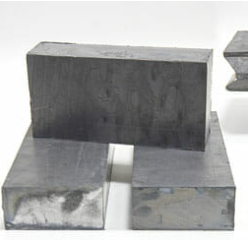
A member of staff, Julie Sanders from CLF, has been asked to construct a lead castle in Astra TA2 for the purpose of radiation shielding during a user experiment.

The blocks are currently stored in a separate building nearby. The blocks require to be stacked on top of each other on an existing metal framework which has been tested and will take the expected weight.

Please write a risk assessment for this task covering the activities:

- Manoeuvring the lead blocks from a storage area in an adjacent building to the area they are to be used;
- Working with lead blocks that are nearly pure lead and therefore fairly soft, often with lead dust on them.

Either use the STFC proforma provided or complete an entry directly into Evotix Assure.

Notes:

- Each block (8”x4”x2”) weighs approx. 11 Kgs and up to 50 blocks will be needed to build the castle.
- Lead is not absorbed through the skin but can be inhaled in the form of lead dust or swallowed if a person eats, drinks, smokes or bites their nails without washing their hands and face after contact with lead.
- High levels of lead in the body can cause headaches, nausea and anaemia. Long term exposure can cause kidney and brain damage.
- The levels of lead in the area have previously been assessed by an Occupational Hygienist. Their report stressed the importance of users wearing PPE when handling lead, laundry service for contaminated clothing, hygiene after contact and a cleaning programme in the area including door handles, toilets and kitchen areas.
- PPE required to work with lead blocks: overalls, safety shoes and gloves. (Note: respiratory protection is only required when cutting lead blocks, not applicable in this instance).
- No pregnant women are allowed to work with lead.

List of Hazards which may apply
Physical injury hazards
- Mobile plant/pedestrians in same area
- Slips trips and falls
- Moving parts of machinery
- Pressure systems
- Manual handling
- Working with mains electricity
- Working at Height/Roof Access
- Hot work
- Access and egress to buildings/specific work areas
Physical Agents
- Ionising radiation
- Hot/Cold objects
- Lasers
- Temperature
- Ultraviolet light
- Noise/vibration
Hazardous Substances
- Hazardous substances (COSHH)
- Asbestos
- Micro-organisms
- Agents that produce fumes/gas
- Clinical or radioactive waste
Miscellaneous
- Weather conditions
- Confined spaces
- Evacuation of all staff on site during an emergency, e.g. fire drill
- Lone working

Exercise 5: Risk assessment departmental RA review
The purpose of this exercise is to carry out a review of the risk assessments within your area/activities/department based on the previous session Evotix Assure demo.
For your area/activities/department, you need to determine:
- If the RA coverage is complete.
- If all RAs are in your opinion “suitable and sufficient” including if they are “in date”.
- Your recommendations for improvement.

- The following questions may be relevant:
  - Is the Department in a strong position in relation to consulting staff and any other relevant people while risk assessments are being written?
  - Is the Department in a strong position on briefing all those involved on completion of the RA?
- Are there any unresolved issues?

The feedback should last no more than 5 minutes.

The most significant risk assessments which apply to my work
Title or description | Written less than 2 yrs ago? | Suitable and Sufficient? | Any missing info? | Areas for improvement
The most significant Risk Assessments for which I am responsible
Title or description | Written less than 2 yrs ago? | Suitable and Sufficient? | Any missing info? | Areas for improvement

Exercise 6: Accident investigation case study
Instructions
- Your job is to interview two people involved in a safety incident to understand what happened.
- You are not trying to establish blame for the incident, but to find out what went wrong and determine what can be done to make sure it doesn’t happen again.
- You are asked to carry out a Why-Why incident analysis (see below) - it is a simple way of logically breaking an incident into causes which when repeated identifies root causes. Your recommendations may not fix all the issues; some recommendations may address more than one root cause.
- The output of this exercise should be a Why-Why diagram identifying the root cause(s) of the incident, and a list of recommendations designed to minimise the chance of this incident being repeated.
STFC’s Safety Management system sets the following expectations for managing work safely:
- All tasks should be risk assessed. A reasonable risk assessment in this case (given the height) may have suggested a ladder was not suitable, or that a restraint system should be used.
- Ladder users should have received basic training, see appendix.
- Ladders should be inspected by the user at the time of use, and annually by a competent person – in this case we refer to the “Group’s ladder inspector” but in reality it would be a departmental role.
Scenario
An accident happened on site two weeks ago. A technician was working up a ladder, fixing some pipework to the top of a large vacuum chamber. He was wearing a hard hat but no other PPE. The ladder collapsed and the technician fell off the ladder and broke his arm. He received immediate first aid and an ambulance was called. He was taken to hospital in the ambulance as he had a suspected head injury. There was no head injury, and his arm had broken cleanly. It was put in a cast and he has now been back at work for two days, on light duties whilst it heals.
The Technician’s name is Harry and he has worked at STFC for 12 years following his apprenticeship here.
His supervisor – who was managing the work – is called Steve and has worked at STFC for 25 years.

When Interviewing Harry – you need to find out:
- What he was asked to do and by whom;
- Why he was using the ladder;
- What training he has had and how aware he was of the relevant rules;
- What he had done to ensure his own safety;
- If there are any other factors that may have contributed to the incident.

When Interviewing Steve – you need to find out:
- What he had asked Harry to do;
- What he had done to ensure the work could be carried out safely;
- What training he had had and how aware he was of the requirements for ladder use;
- What he has discovered whilst investigating the incident.

The Investigation:
Please remember that all sort of things can cause accidents or contribute to the effects, so you need to look at many areas:
Immediate causes – Equipment Design, Working Environment, Inspection and Maintenance, Risk Perception, Motivation, Pressure, Fatigue, Compliance, Competence.
Organisational Issues – Management/Supervision, Communications, Recruitment/Selection, Training, Planning, procedures, Incident Management and Feedback.
External influences – Regulations, Political environment, Customers, Public Perception, economic Factors.
Corporate Influences – Organisational Change, Ownership and Control, Safety Management System, Procurement.
Activities:
- Construct a Why – Why diagram relating to the accident.

- Can you distinguish between Active Failures and Latent Failures?

- What sort of interventions might have made a difference on a timescale of:
  - Minutes?
  - Weeks?
  - Months?
  - Longer?
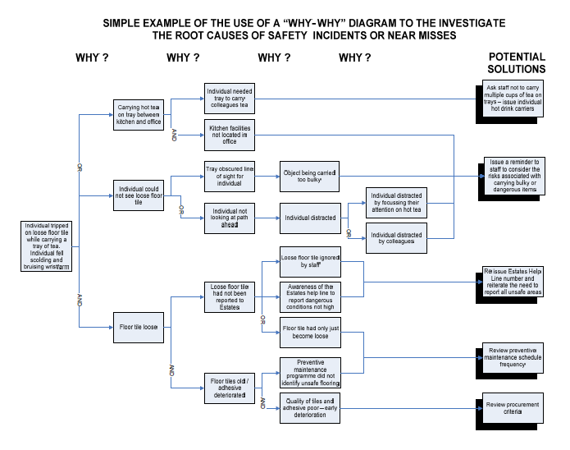
Use of Ladders in STFC
When to use:
Ladders or stepladders should only be used if:
- The task does not require working in the same high point for more than 30 minutes;
- The maximum height of any work area is 5m (this means the operatives head may be slightly higher than 5m during the work);
- A handhold is available on the ladder; and
- Three points of contact can be maintained at the working position while undertaking the task.

Selection and use:

The following requirements apply to all ladder use:

- Consideration should be given to the type of work involved – metal ladders should not be used for electrical works;
- Domestic Ladders should NOT be used – all ladders must meet UK Class 1 or EN131 and be marked as such;
- Access ladders for scaffold must be secured at the top and another point;
- Unsecured ladders must be footed by a person or ladder mate; and
- Distractions should, if at all possible, be avoided by those working on or footing a ladder (for example mobile phones should not be answered etc.).

Maintenance:

- The treads and feet of ladders should be kept clean to prevent slips during use;
- Broken feet can be repaired/replaced (if parts are available); and
- If a ladder has a damaged rail or treads it should be removed from service and disposed of.

Storage:

- Ladders should be removed from the work area following the task, and stored in a clean and dry location in a way to minimise the risk of possible damage from other objects and area users.

Registration and inspection:

- Ladders should be registered with the appropriate person, see SHE Group, who will give the ladder a unique identification number.
- The appropriate person should record:
  - Unique identification number
  - Type of ladder;
  - Size; and
  - Storage location.
- The unique identification number provided should be indelibly marked on the ladder;
- In addition to regular inspection by the user, all ladders should be checked on an annual basis by a competent person, see appendix 4.

Exercise 7: Environmental SHE Code Review

Group 1 - SHE Code 27: Receipt & Dispatch of Hazardous Substances
The purpose of this exercise is to prepare a short flip chart presentation for the course summarising the implications of the code for line managers or supervisors in a technical environment.
The presentation should last no more than 5 minutes, and include at least the following at bullet level:
- The purpose of the code.
- The definitions of hazardous substances and dangerous goods.
- The roles of the Dangerous Goods Safety Advisor and Logistics personnel.
- Who are the Dangerous Goods Safety Advisors in your Departments?
- The main duties of staff.
- The main duties of Line Managers.
- Summary of guidance available in the SHE code appendices.

Group 2 - SHE Code 31: Controlled and Hazardous Waste
The purpose of this exercise is to prepare a short flip chart presentation for the course summarising the implications of the code for line managers or supervisors in a technical environment.
The presentation should last no more than 5 minutes, andinclude at least the following at bullet level:
- STFC’s responsibilities (Code purpose).
- The definitions of controlled and hazardous waste.
- The role of the Waste Disposal Officer.
- Who is the Waste Disposal Officers for your Department?
- The main duties of staff and Line Managers.
- Summary of information and guidance available in the SHE Code appendices.

Group 3 - SHE Code 41: Controlling Pollution to Air, Water and Land
The purpose of this exercise is to prepare a short flip chart presentation for the course summarising the implications of the code for line managers or supervisors in a technical environment.
The presentation should last no more than 5 minutes, and include at least the following at bullet level:
- What operations/activities on STFC sites require authorisation, permit or consent?
- What authorisations, permits, consents or licenses does STFC hold and who is responsible for obtaining them?
- What are the main duties of Line Managers?
- Summary of guidance available in the SHE Code appendices.

Exercise 8: SHE Code 8 Travel on Council Business

Bite Size completion

Notes:

Exercise 9: Improving safety culture

A healthy safety culture is one where there is… | Actions I can take in my workplace/activity | Actions STFC can take
Visible Commitment to Safety by Management

Workforce Participation and Ownership of Safety Problems and Solutions

Trust Between Employee and Management
Good Communications
A Competent Workforce

Extract from HSE Briefing Note on Human Factors and Safety Culture

A healthy safety culture is one where there is… | This is shown when management… | … and is helped when management…
Visible Commitment to  Safety by Management | - Make regular useful visits to site  - Discuss safety matters with frontline personnel  - Will stop work activity for safety reasons regardless of cost  - Spend time and money on safety e.g. to provide protective equipment, safety training, and conduct safety culture workshops or audits  - Will not tolerate violations of procedures and will actively try to improve systems to discourage violations e.g. plan work so that short cuts aren’t necessary to do the work in time. | - Makes time to visit site (not just following an incident)  - All managers consistently show commitment  - Has good non-technical skills (e.g. communication skills;)  - Are also interested in workforce safety when they are not at work, e.g. provide information on domestic safety  - Shows concern for wider issues e.g. wellbeing; stress/health  - Actively sets an example (e.g. always conform to all safety procedures)
Workforce Participation  and Ownership of Safety  Problems and Solutions | - Consults widely about health and safety matters  - Does more than the minimum to comply with the law on consultation  - Seeks workforce participation in:  - setting policies and objectives  - accident/near miss investigations | - Supports an active safety committee  - Have a positive attitude to safety representatives  - Provides tools or methods that encourage participation in:  - behavioural observation  - programmes & incentive schemes that promote safety
Trust Between Employee  and Management | - Encourages all employees and contractors to challenge anyone working on site about safety without fear of reprisals  - Keeps their promises  - Treats the workforce with respect | - Promotes job satisfaction/good industrial relations and high morale  - Promotes a ‘just’ culture (assigning blame only where someone was clearly reckless or took a significant risk)  - Encourages trust between all employees
Good Communications | - Provides good (clear, concise, relevant) written materials (safety bulletins, posters, guidance)  - Provides good briefings on current issues day to day and in formal safety meetings; listening and feedback | - Encourages employee participation in suggesting safety topics to be communicated  - Provides specific training in communication skills  - Has more than one means of communicating
A Competent Workforce | - Ensures that everyone working on their sites is competent in their job and in safety matters | - Is supportive  - Has a good competence assurance system

Exercise 10: Felt leadership

Influences on safety culture | Actions I can take to improve my leadership | Support I need
What do I say?

How do I act?

What do I prioritise?
What do I measure?
What sort of shadow do I cast?

Notes

