STFC Internal SHE Compliance Lead Auditor Course Workbook
Note: This document contains the exercises to be use as part of the above course.

Name _____________________________

STFC Internal SHE Compliance Lead Auditor Course
Outline programme
** Please note timings are approximate and will be adjusted to suit progress through the course material **

09:00 to 09:10 | Introduction and programme
09:10 to 09:30 | Purpose of the audit report
09:30 to 09:50 | Format of the audit report
09:50 to 10:10 | Before you start - has fieldwork finished?
10:10 to 10:40 | Converting evidence to narrative
10:40 to 11:00 | Break
11:00 to 11:30 | Converting narrative to actions
11:30 to 12:00 | Rating actions
12:00 to 12:25 | Determining overall audit rating
12:25 to 13:00 | Summary and questions.

STFC Internal SHE Compliance Lead Auditor Course
Personal Action Log
Session Title | Action | Notes

Exercise 1: Converting audit evidence to a narrative
Produce a one/two sentence statement for each line of evidence
What type of activities are undertaken within your workshop which require the safe disposal of waste? | The production of swarf, metal waste, waste coolant, some special metal waste which is considered to be hazardous. | The machining of plastics and metals. There is no cutting fluids used as only dry work carried out. | The use of machine oils and wire erosion equipment, chemicals, coolants. These produce Swarf. | The use of chemicals and materials for target making. They tend not to be recycled but will always be stored in a flammable cabinet.
What percentage of waste produced in the workshop is considered to be highly flammable, toxic or carcinogenic? | About 5% of waste would be classed as this - very little in total to what is produced during general machining. | Try to minimise hazardous waste but do have chemical waste stored locally until ready to be removed off site. | Only the machine oil which is stored locally until ready for removal. | Would contact the WDO for removal of any such waste, this is very rare.
Where is the location of the nearest Waste Control Points to your workshop? | Immediately outside the workshop. | Just outside the workshop area. | There is a bunded area close to the workshop. Also, inside the workshop there is a chemical cabinet. | Use the scrap metal bins in the corridor close to the laboratory.

What type of activities are undertaken within your workshop which require the safe disposal of waste? | The code shall apply wherever STFC activities (including those of staff and facility users, visitors, contractors and tenants on STFC sites), require the safe collection, transport, handling, storage, recycling and disposal of waste or scrap materials (for example scrap metal).
What percentage of waste produced in the workshop is considered to be highly flammable, toxic or carcinogenic? | All waste is potentially harmful but it is defined as hazardous if, for example, it is highly flammable, toxic or carcinogenic.
Where is the location of the nearest Waste Control Points to your workshop? | Waste Control Points (WCP) are defined STFC locations where controlled and hazardous wastes can be stored temporarily prior to removal, disposal, incineration and treatment by a waste disposal contractor. Such locations are designed to ensure that stored wastes do not present an environmental hazard and are the responsibility of a Waste Controller.

Generate narratives for these facts
- The workshops and laboratories would typically generate waste which are covered by the safety code, such as metal waste, coolant, chemicals and distinct waste such as special metals and plastics.
- Only very small quantities of the overall waste produced by the workshops and laboratories would be considered highly flammable, toxic or carcinogenic. Risk controls are applied to this waste.
- Waste control points are located immediately outside the workshops and the laboratories with additional chemical cupboards located inside the workshops.

Exercise 2: Converting a narrative to actions
Produce a set of actions from the following audit narratives.
Audit Narrative | Actions required
It wasn’t clear if waste disposal forms for both external and internal waste disposal stream are retained. (4.5.9)
The quantities of construction waste are reported by the main contractors for large construction projects. However, it appears that this information is not being submitted as part of an annual review of waste for inclusion in the departmental SHE improvement plans. (4.3.2)
A new contract has been recently placed on Select Environmental Services to undertake both the RAL and Chilbolton site hazardous waste disposal. It was noted that they did not undertake a site inspection prior to submitting their tender and a copy of Safety Code 31 was not provided to them. (2)
The plan is that monthly reports will be generated by Select Environmental Services for all waste streams. All bins are microchipped which allows for the measurement of their weight, allowing detailed quantities to be assessed for each building location. (4.3.2)

Safety code references.
- 4.5.9 Retain WDFs, HWCN and CWTN for at least 3 years and maintain a record of wastes disposed. Appendix 4 details the Hazardous Waste Consignment Note procedure.
- 4.3.2 On an annual basis, review the waste arising from their Department's activities and consider the scope for waste elimination, minimisation, re-use, re-cycling or disposal reporting this through Departmental SHE Improvement Plans, see STFC SHE Code 7, SHE Improvement Planning.
- 2 The code shall apply wherever STFC activities (including those of staff and facility users, visitors, contractors and tenants on STFC sites), require the safe collection, transport, handling, storage, recycling and disposal of waste or scrap materials (for example scrap metal).
Exercise 3: Rate the actions determined in exercise 2
Produce a set of actions from the following audit narratives.
Audit Narrative | Actions required | Rating
It wasn’t clear if waste disposal forms for both external and internal waste disposal stream are retained. (4.5.9)
The quantities of construction waste are reported by the main contractors for large construction projects. However, it appears that this information is not being submitted as part of an annual review of waste for inclusion in the departmental SHE improvement plans. (4.3.2)
A new contract has been recently placed on Select Environmental Services to undertake both the RAL and Chilbolton site hazardous waste disposal. It was noted that they did not undertake a site inspection prior to submitting their tender and a copy of Safety Code 31 was not provided to them. (2)
The plan is that monthly reports will be generated by Select Environmental Services for all waste streams. All bins are microchipped which allows for the measurement of their weight, allowing detailed quantities to be assessed for each building location. (4.3.2)

Exercise 4: Determining the overall rating (1)
Determine the overall rating for the following example.
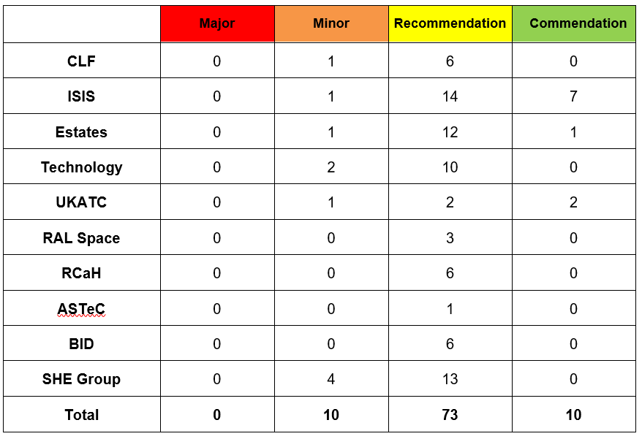
- Some departments have staff trained as Waste Disposal Officers (WDO) who undertake the management of any hazardous waste disposal. The majority of WDO training has now expired.
- The majority of hazardous waste is disposed directly through the use of external waste disposal contractors. Very few departments undertake a duty of care audit regarding the engagement of these contractors. Likewise, the waste carrier registration and the waste management disposal licence for these contractors is rarely obtained.
- Any unknown waste is either assessed through the WDO route or through external waste disposal contractors who offer a testing facility.
- Copies of waste disposal forms, hazardous waste consignment notes, controlled waste transfer notes and chemical analysis results tend to be retained as hard-copies only with no electronic back-up.
- Very little of the hazardous waste arising from department activities is quantified and included in the Departmental SHE Improvement Plans.
- Registration of the various STFC sites in respect of waste management activities is now undertaken at a UKRI level. It is noted that the current registration expired in June 2021.
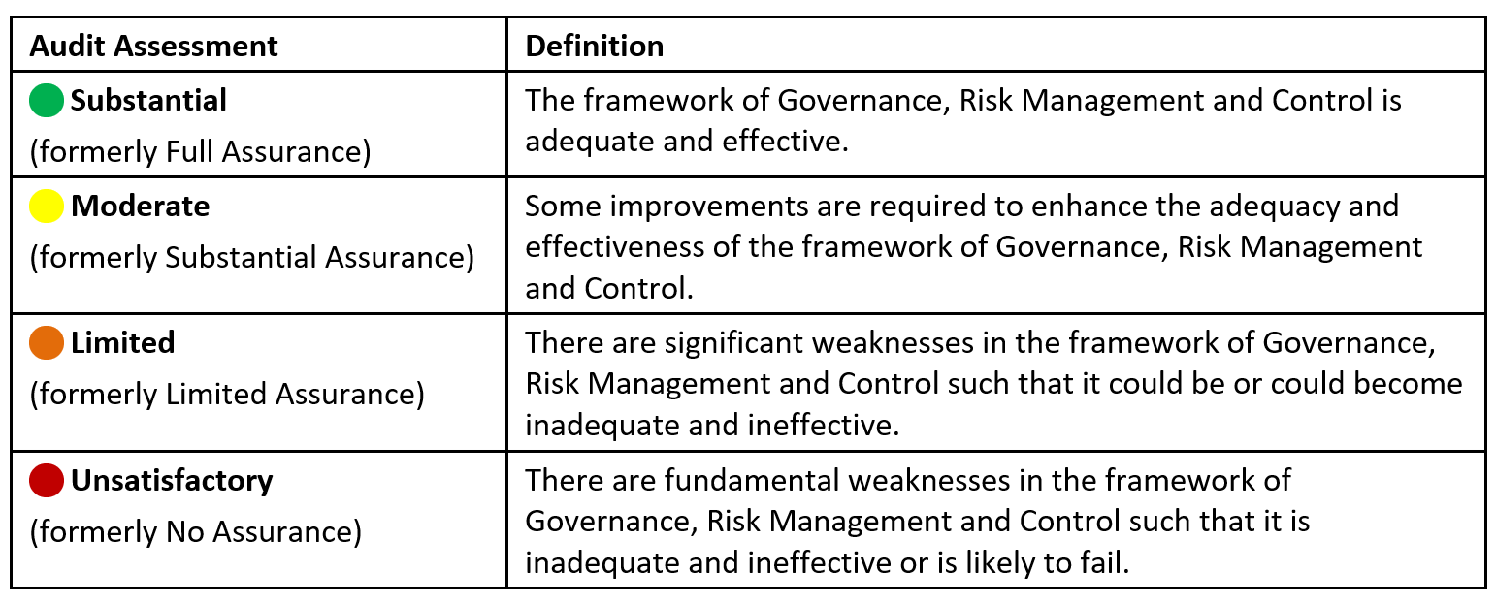

Overall Audit Rating = _______________

Exercise 5: Determining the overall rating (2)
Determine the overall rating for the following example.
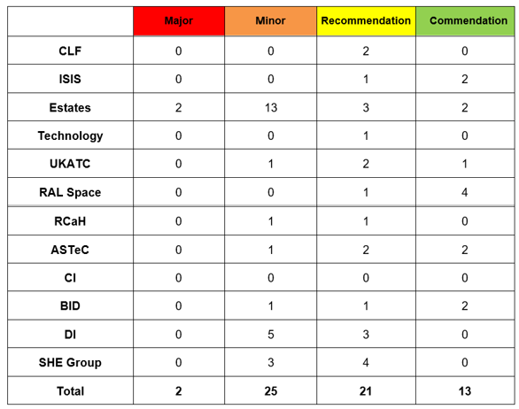

- Many department procedures are low-risk managed activities of short duration, where contractors are for example employed to undertake the installation or maintenance of existing site equipment.
- Higher-risk activities are also undertaken involving the use of principal contractors along with sub-contractors for specialist activities.
- Not all departments have a comprehensive awareness of the code, with many of the relevant personnel who manage contractors having taken on these roles without formal training.
- The majority of hazards identified as part of the management of contractors are suitably controlled and monitored, with many departments employing permit systems for specific hazard management.
- The communication of contractor activities arranged by the Estates department is generally perceived as poor and it is common for other departments to state that they have no prior knowledge of the planned contractor work.
- Generally, contractors appear to have a low standard of health and safety awareness in the work they undertake for the STFC. This is reflected in the large number of health and safety incidents reported involving the use of contractors.
Overall Audit Rating = _______________

Notes

