Room Hazard Details as of: | Click here to enter a date.

Building and  Room Number |  | Local Room  Name |  | Department &  Division

Hazard | Warning | Hazard Description | Hazard Location

Additional Hazard / Emergency Information
Click here to provide brief details of any other significant safety hazards or information that people entering the room in an emergency need to know about.

Power and Gas Isolation Details
Click here to provide brief details of how to isolate the electrical, mains gas and any compressed gas supplies to the room. This information is for people to use in the event of an emergency.
Primary Contacts for Room
Name |  |  | Direct Dial |  | Mobile / Out of Hours | Location (Building & Room No.)

Select the emergency details for your site from the options on this drop down list

Document Owner:

Cut and paste the relevant Hazard and Warning from this table (DO NOT Print this page)
Hazard | Warning | Hazard | Warning
 | Corrosive Material |  | Oxidant Material
 | Explosive Material |  | Toxic Material
 | Flammable Material or High Temperature* |  | Low Temperature or Cryogenic material*
 | Ionising Radiation |  | Non-ionising Radiation
 | Laser Beam |  | Strong Magnetic Field
 | Noise |  | Danger: Electricity
 | Biological Risk |  | General Danger
 | Gas under pressure | 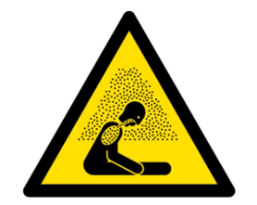 | Asphyxiation Risk

* Select description that applies

