STFC Risk Assessment template for staff member working from home
Staff name which assessment refers to:
Line manager name:
Dept/Site (based at):
Assessment date:
Step 1  What are the hazards/tasks? | Step 2  How might the named person be harmed? | Step 3:  What are you already doing?  (see guidance attached) | What is the level of risk? |  |  |  | What further action is necessary? | Step 4:  How will you implement identified actions?
 |  |  | H  Harm | L  Likelihood | R  Risk |  |  | Action by whom | By when | Done
Working from home | Working from home for long periods can lead to stress, anxiety or depression. | - Regular catch ups should be arranged between staff member and their line manager.  - Should the staff member feel they are suffering from symptoms of stress, anxiety or depression, they should inform their line manager.  - Staff should read the ‘Wellbeing’ section on in.focus for more information on resources available, e.g. Employee Assistance Programme.  - Staff should keep themselves informed of STFC current issues through regular catch ups with their line manager and attending staff forums (try to avoid meeting clashes at these times). | M | UL | Med
Lone working | If anyone working from home also lives alone and collapses, there may be a delay in medical assistance being summoned. | - Inform line manager of any:  - pre-existing medical conditions which could affect staff member’s ability to work from home; or  - any health issues which could be exacerbated by home working.  - Any staff member who does not wish to discuss these matters with their line manager should consult Occupational Health via HR.  - Staff should be in regular contact with either their team or line manager.
Using work equipment at home | Electrical item may get hot and lithium batteries in laptops can catch fire if they overheat. | - All laptops should be switched off (power source disconnected) at the end of the working day.  - All work equipment is inspected prior to use (see Appendix 1 below).  - Any bulging of batteries, laptop is powered off and returned to relevant IT Dept for replacement battery to be fitted.  - All work electrical items are part of a site PAT testing programme. All items to be returned to the workplace when notified that PAT testing is required.  - Consider aids to keeping electrical items cool, e.g. laptop cooling fan. | M | VUL | Low
Working at a computer during working hours | Sitting for long periods can cause musculoskeletal injuries and headaches from eye strain. | - Staff have a suitable workstation at home in addition to their site workstation. If equipment such as DSE equipment and additional office furniture is required at home this will be required to be agreed and funded by their line manager.  - A DSE workstation assessment is carried out by staff who routinely work an agreed pattern of at least one day a week from home.  - DSE training is available to staff to remind them of the proper set up of their DSE equipment.  - Any issues highlighted by the workstation assessment are discussed with the line manager. | S | UL | Low
Lifting heavy items at home for occupational reasons | Heavy lifting can cause musculoskeletal injury | - All staff receive mandatory training every 5yrs on good manual handling practice.  - Staff should try to avoid moving equipment, e.g. monitors and computers once they are in place, i.e. have a fixed work station at home. | S | UL | Low
Working at home | Staff member may trip over loose cables, files or other items stored at home. | Workstations are kept tidy and items where possible are not stored on the floor. | S | UL | Low
Working at home | Staff member may be injured or suffer ill-health while working at home. Lack of investigation may increase likelihood of it happening again. | All occupational SHE related incidents are reported to SHE Assure using the portal. | S | UL | Low
Distribution List: |  | Signed: |  |  |  | Date:
[Line manager name]
Has the assessment been entered into the SHE Assure database? |  | Yes No SHE Assure ref no:
Step 5 Review Date: |  | - Review your assessment to make sure you are always improving the identification of hazards and control measures.  - If there is a significant change in your workplace, remember to check your risk assessment and where necessary, amend it.

Appendix 1 – SHE Information Poster regarding inspection of electrical work items used at home
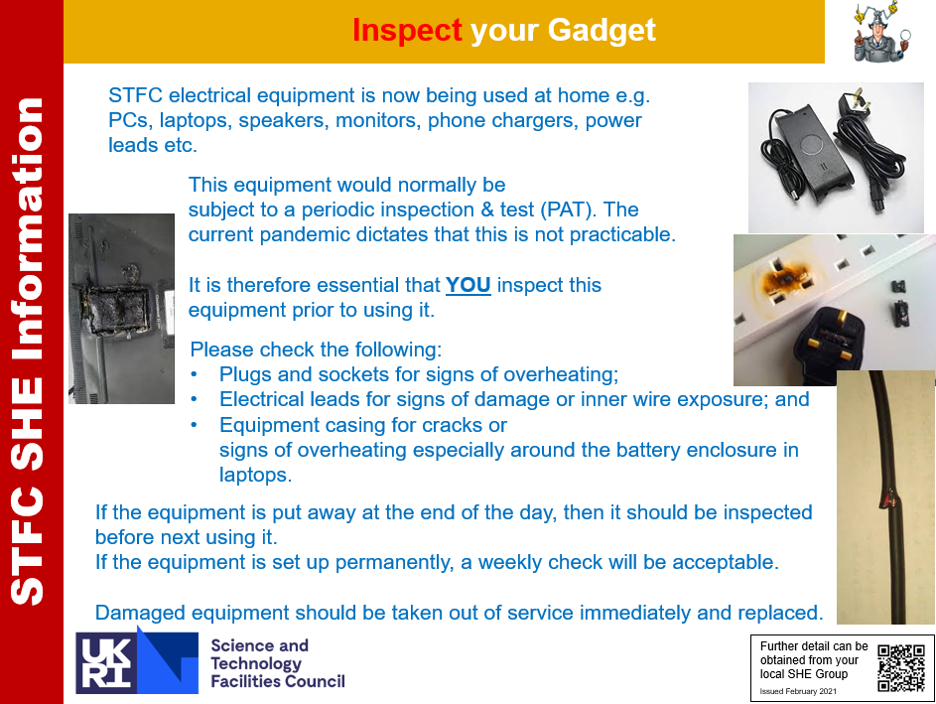

What is the level of risk? For each hazard, choose the ‘Harm’ and ‘Likelihood’. Choose ‘the most likely reasonably foreseeable injury’ and not just the worst case outcome. For example, it is very unlikely that someone would be killed from falling from a footstool, the most common injury is likely to be a minor injury which may or may not require attention from a First-Aider.

E.g. if Harm was ‘Moderate’ and Likelihood ‘Unlikely’ the Risk would be ‘Medium’.

 |  | If control measures are not adhered to potential harm is likely to be:
HARM | Major | Fatality | High | High | V High | V High
 | High | Fatality or life changing injuries or serious health effects | Med | Med | High | V High
 | Moderate | Time off work, e.g. broken bones, stress or musculoskeletal injury | Low | Med | Med | Med
 | Slight | Minor injury which may or may not require First-aid treatment | Low | Low | Low | Low
 |  |  | Very Unlikely | Unlikely | Likely | Very Likely
 |  |  | Conceivable but difficult to realise. Would require a combination of several failures | Can be envisaged but is unlikely. Never previously happened in STFC | Can be anticipated to happen. Has previously been known to happen in STFC | Can be anticipated to happen. Has previously been known to happen on site
 |  |  | LIKELIHOOD
[Please note this matrix is reversed on SHE Assure, this is due to the software design and currently is unable to be altered. However, the meaning of the risk categories are the same.]
Where:
Low Risk | No additional controls are necessary unless they can be implemented at very low cost (in terms of time, money and effort) or there is a mandatory requirement within legislation. Actions to further reduce these risks can be assigned low priority.
Medium Risk | Consideration should be given as to whether the risks can be lowered, where applicable, to a low risk level, but the costs of additional risk reduction measures should be take into account. The risk reduction measures should be implemented within a defined time period.
High Risk | The controls put in place are critical and it is imperative that they are monitored by a line manager (or equivalent) on a regular basis to ensure they are in place. Risk reduction measures should be contemplated as per the hierarchy and favour engineering controls over administrative controls and PPE. Additional controls may require extra resources and these would be justifiable.
Very High Risk | Additional control measures must be implemented to reduce the risk, regardless of cost, or a decision taken to terminate the activity until the risk level can be reduced.

What are you already doing? The ‘Control Hierarchy’ provides a simple prompt to consider the various types of control measure that are or could be established for any given hazard. The examples below are provided for illustration but are not an exhaustive list.

Eliminate/Substitute | Redesign job or substitute a substance so hazards are removed or eliminated. For example, avoid working at height or substitute a carcinogenic substance with a less hazardous substance.
Engineering Controls | For example: Local Exhaust Ventilation (LEV) to control risks from dusts or fumes; Interlocks/guarding of machinery; Access control; Emergency stop within reach. Also, the complete enclosure of the operator or the hazardous machinery/equipment.  Give priority to measures which protect collectively over individual measures.
Administrative Controls | For example: training; reducing the time workers are exposed to hazards (e.g. by job rotation); prohibiting lone working; prohibiting use of mobile phones in hazardous areas; safety signage. Also, performing risk assessments, safe systems of work or a laser standing order.
Personal Protective Equipment (PPE) | Only used as a control measure after all the previous measures have been considered and determined to be ineffective in controlling the risks to a reasonably practicable level. For example: safety shoes, gloves, safety spectacles, hard hat, fall arrest harnesses. It is not sufficient to say ‘PPE used’, the type of PPE required must be specified.

Note: if one section such as PPE is not applicable, do not delete it but instead insert “PPE: N/A”. This shows that it has been considered and deemed not relevant for this activity.

