Instructions on how to locate training courses on Totara (3 options)

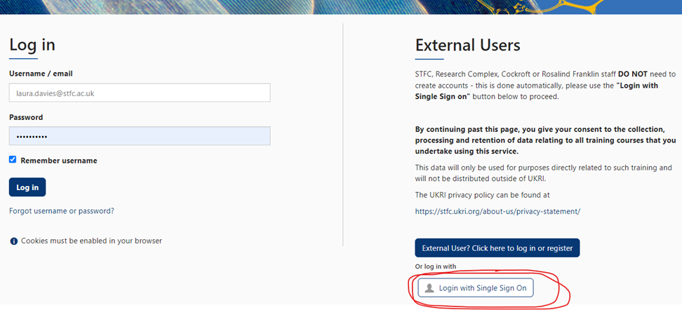
Option 1: When following a direct link to a course, click on the ‘Login with Single Sign On’ link highlighted below. This will take you directly to the course you have selected.

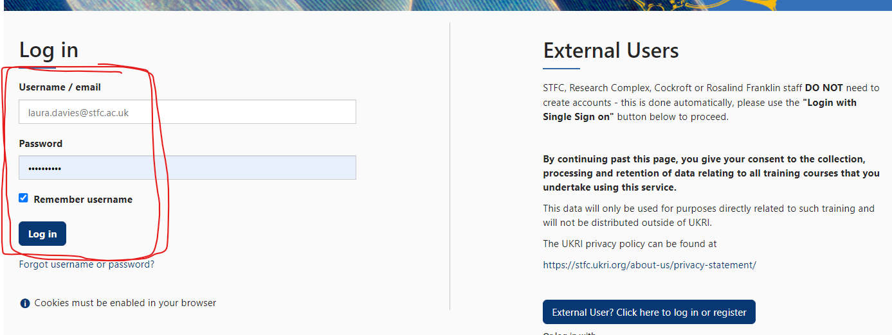
Option 2: You have no direct link to follow. Therefore, log in with Username and Password and use the search function on Totara as illustrated on the images below. This will take you to every course with this key word in the title.

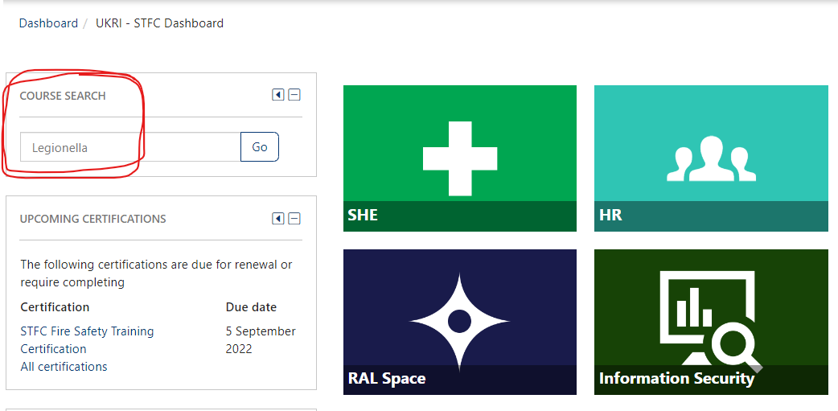
For example, if looking for the iHasco Legionella course, search for a key word such as ‘legionella’.

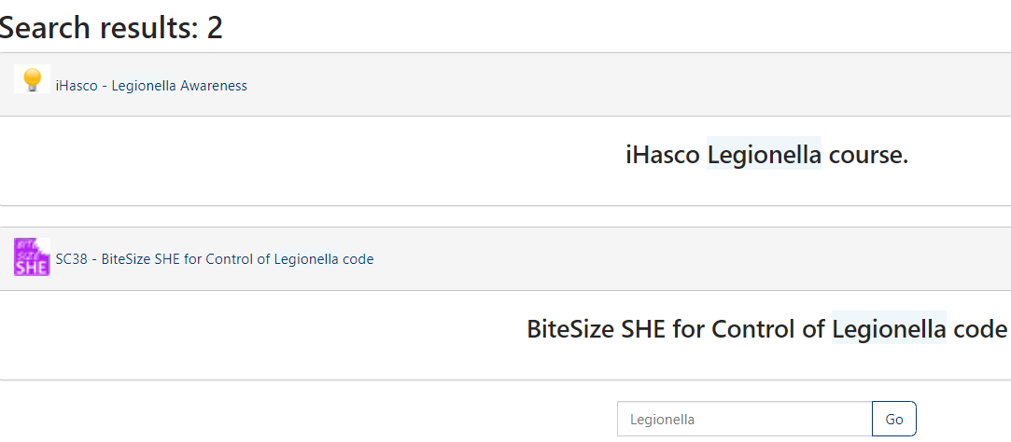
There are 2 results for ‘Legionella’, the iHasco awareness course and the Bitesize course for SHE code 38: Legionella.

Option 3: You can peruse the library of SHE Courses by clicking on SHE as indicated below.
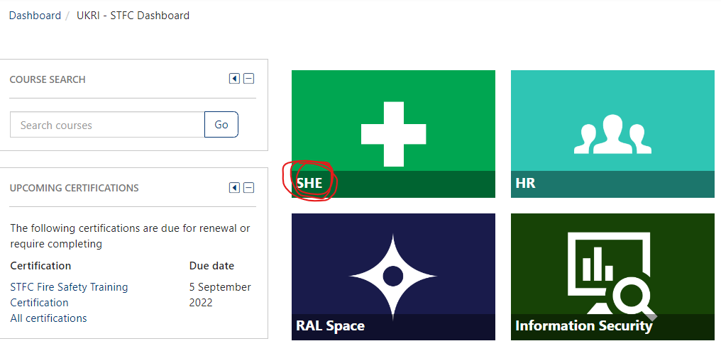

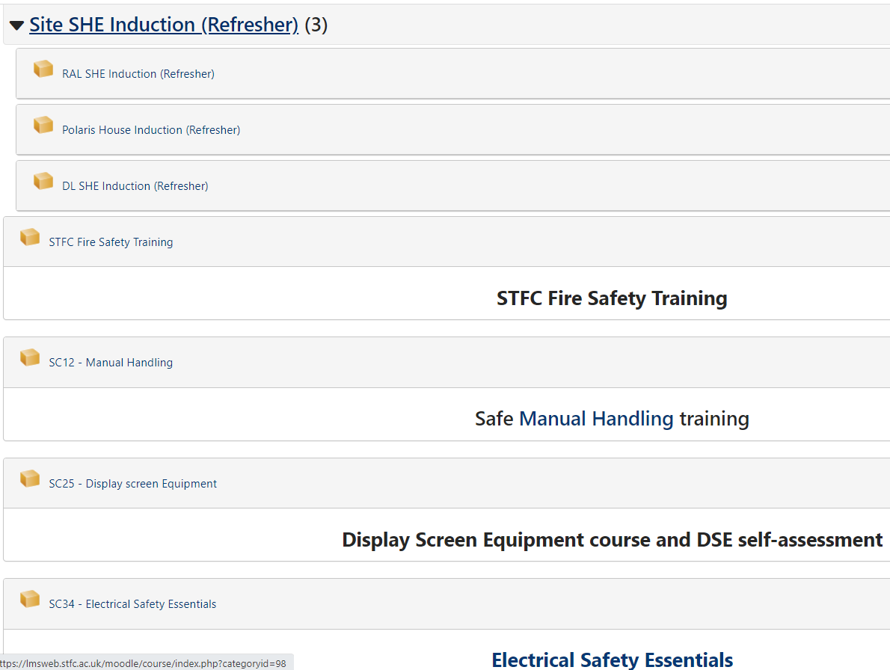
This will take you to a library of SHE courses. The 2 key categories of interest are: Codes and Mandatory. If you are looking for mandatory courses such as SHE site induction, fire safety, manual handling, DSE training, electrical essentials, asbestos essentials or STFC H&S Arrangements then click on ‘mandatory’.

However, if you are looking for a training course by Code then click on ‘Codes’ and choose your subject area. Again, there is a search function on this page to assist you.
